About the Dataset:
This Dataset contains information about Immigration to Canada from 1980 to 2013. In this Project we have used Tableau Public to generate visualizations.
Dataset Source: International migration flows to and from selected countries - The 2015 revision.

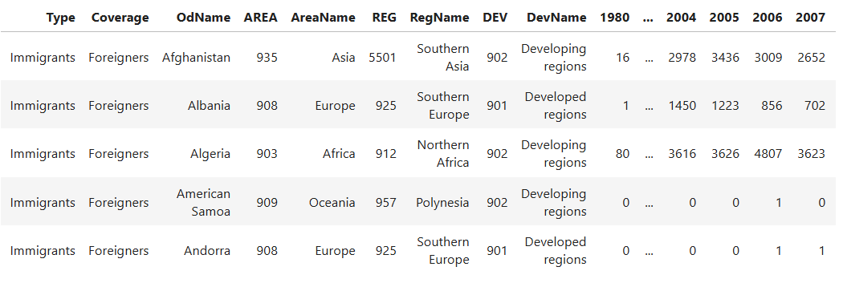
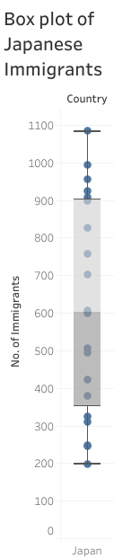
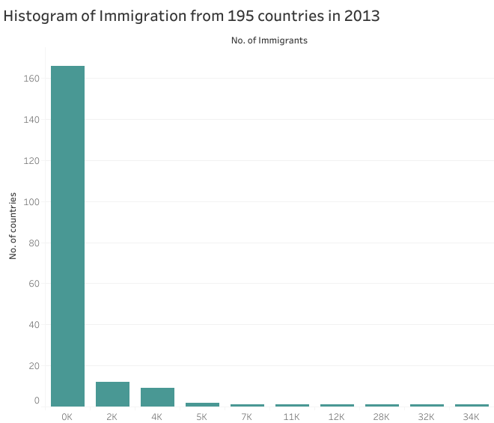
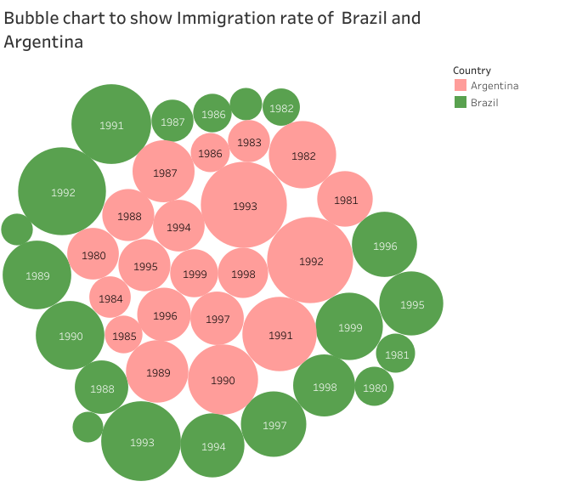
Dashboard
